**Introduction**

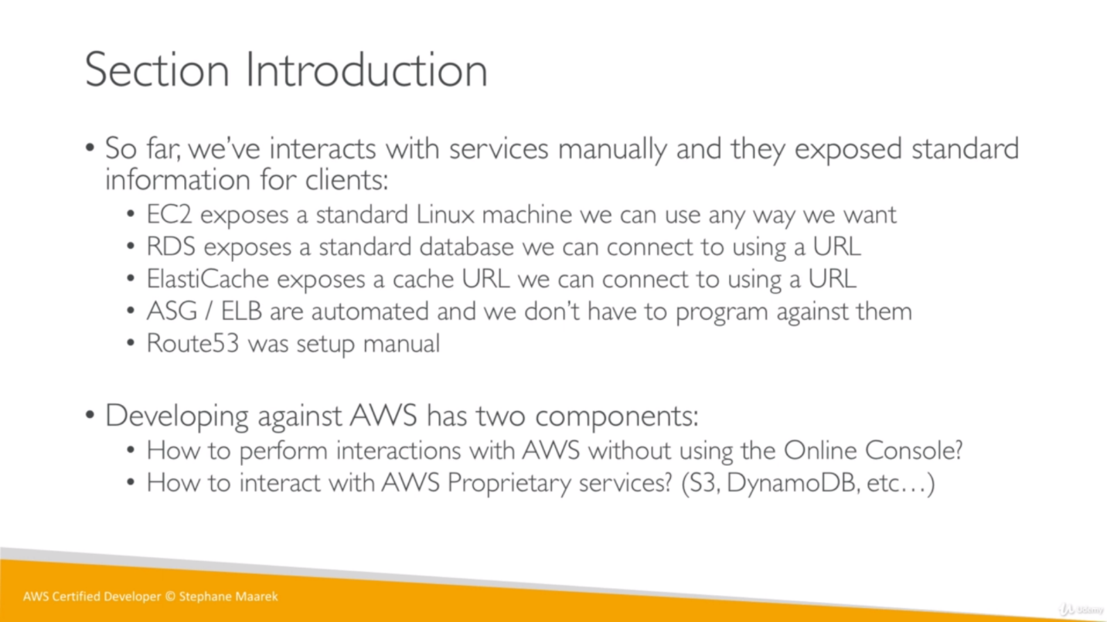

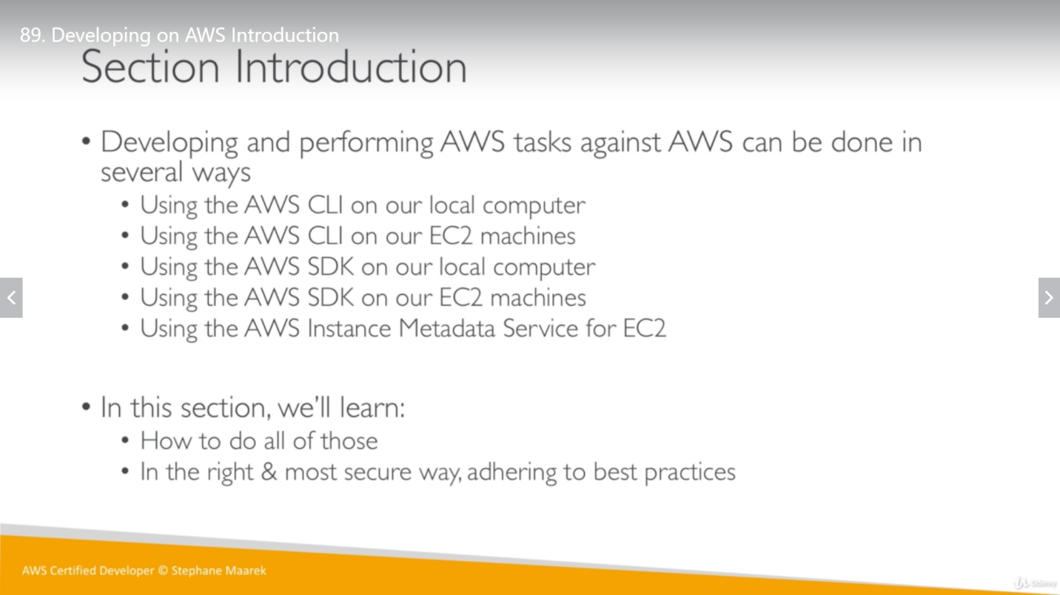

**Bad way:** SSH into an EC2 instance, do aws configure with user access key and fetch the service.

**Good way:** SSH into an EC2 instance, attach required policies for user, do aws configure for user first (without the credentials that we had downloaded from IAM roles) and then use services.

**AWS CLI on Local computer:**

**Access Key:**

Access keys are used to sign programmatic requests to the AWS CLI or AWS API (directly or using the AWS SDK).

We have a user AshvaniV1, which is having an access key which can be downloaded. This file will have access key id and secret access key. This will be required for *aws configure* command as mentioned below.

**AWS setup for CLI:**

Imp** *One time task and we will not use these credentials any time later for EC2 instances.*

Download AWS CLI and setup check as *aws –version*. Once downloaded and installed perfectly, configure it as *aws configure*

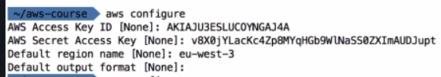

Now the required files would have been created at respected place and we can check them as:

*ls ~/.aws*

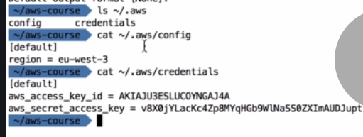

**Summary**: Overall, we have a user AshvaniV1, which have granted access for services by root account using policies attached to it. This user has access key which can be used to have these services accessed from CLI.

We have aws command line, which been configure for a user and will allow us services based on policies attached to user.

**AWS CLI on EC2:**

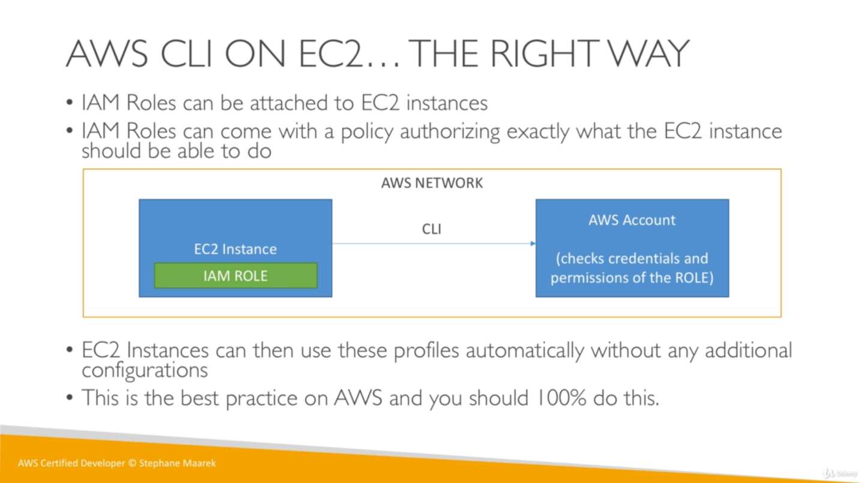

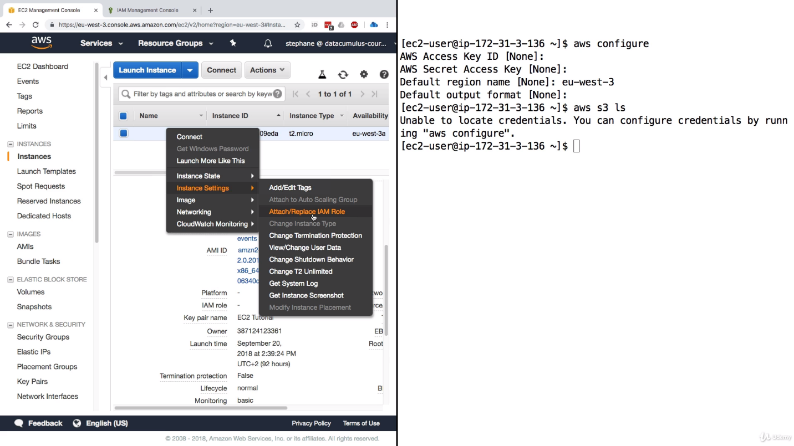

We can create a role for EC2 instance (for example create role to access S3 bucket using “AmazonS3ReadOnlyAccess” Policy) and then attach this role to EC2 instance so we will be able to access from this EC2 instance.

**Access EC2 instance on CLI:**

We SSH EC2 instance on AWS CLI and do the rest things. (Even if we SSH EC2 instance into **PowerShell CLI,** we can do aws configure because EC2 is a Linux instance which have existing AWS CLI in it. Version might not be latest, but we can work with this as well.)

We want to access S3 bucket so first add required policies (AmazonS3ReadOnlyAccess) to the IAM user, attach IAM user to the instance and we will be able to access S3 bucket from CLI.

imp**

One instance can have only one IAM role but one IAM role can be attached to many EC2 instances.

**S3 CLI commands:**

aws s3 ls: to list down the buckets in S3. To see the data from any bucket can use below command.

*aws s3 ls s3://ashvanivashist/images/*

aws s3 cp: To copy/download a file from s3 to local (EC2 instance)

*aws s3 cp s3://ashvanivashist/images/coffee.jpg coffee.jpg*

*ll*: (it will show all data in EC2 instance)

there are many more command available online.

**Policy:**

We can use policies managed by AWS or we can create our own inline/global policies. (inline mean it will be created and used by only that role)

We have an online simulator where we can choose a policy which we had created in our account and test for all access, what is applicable on that policy and what not.

**AWS CLI Dry Run:**

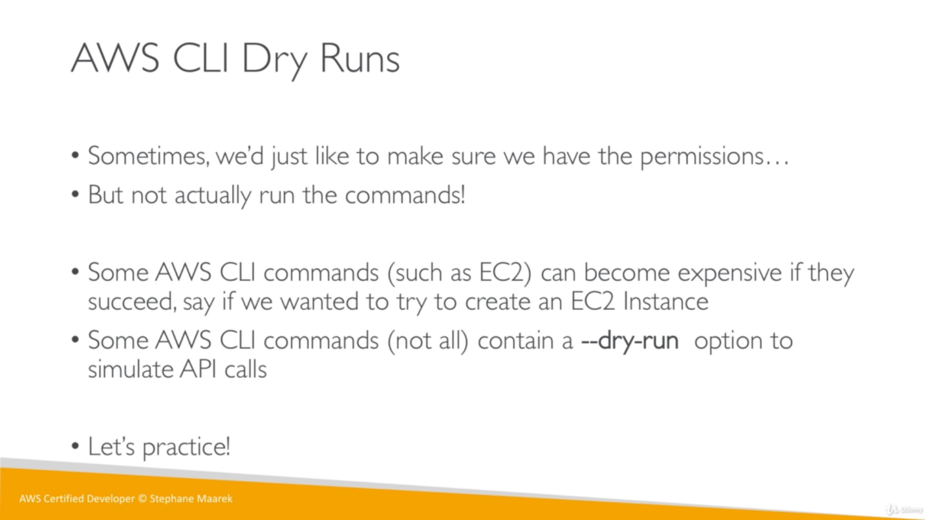

Open AWS CLI and run below command:

Image id: AMI id of instance

We hit a command to run an EC2 instance, which got failed because we don’t have a role (which have policy that allow us to run instance from CLI).

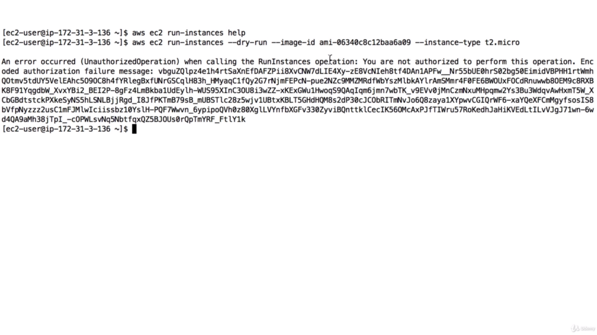

If we want to run this instance from CLI, we must create a role which have a S3 policy to run the instance.

So, we must go to policy, and edit it then add additional permissions by choosing the service EC2 and choose *RunInstances* under write Access level.

So now it will show that command would have passed but got failed because of dry run.

**AWS CLI STS Decode Errors:**

Above authorization failure message can be decoded using command in AWS CLI as mentioned below. It will give us JSON format result.

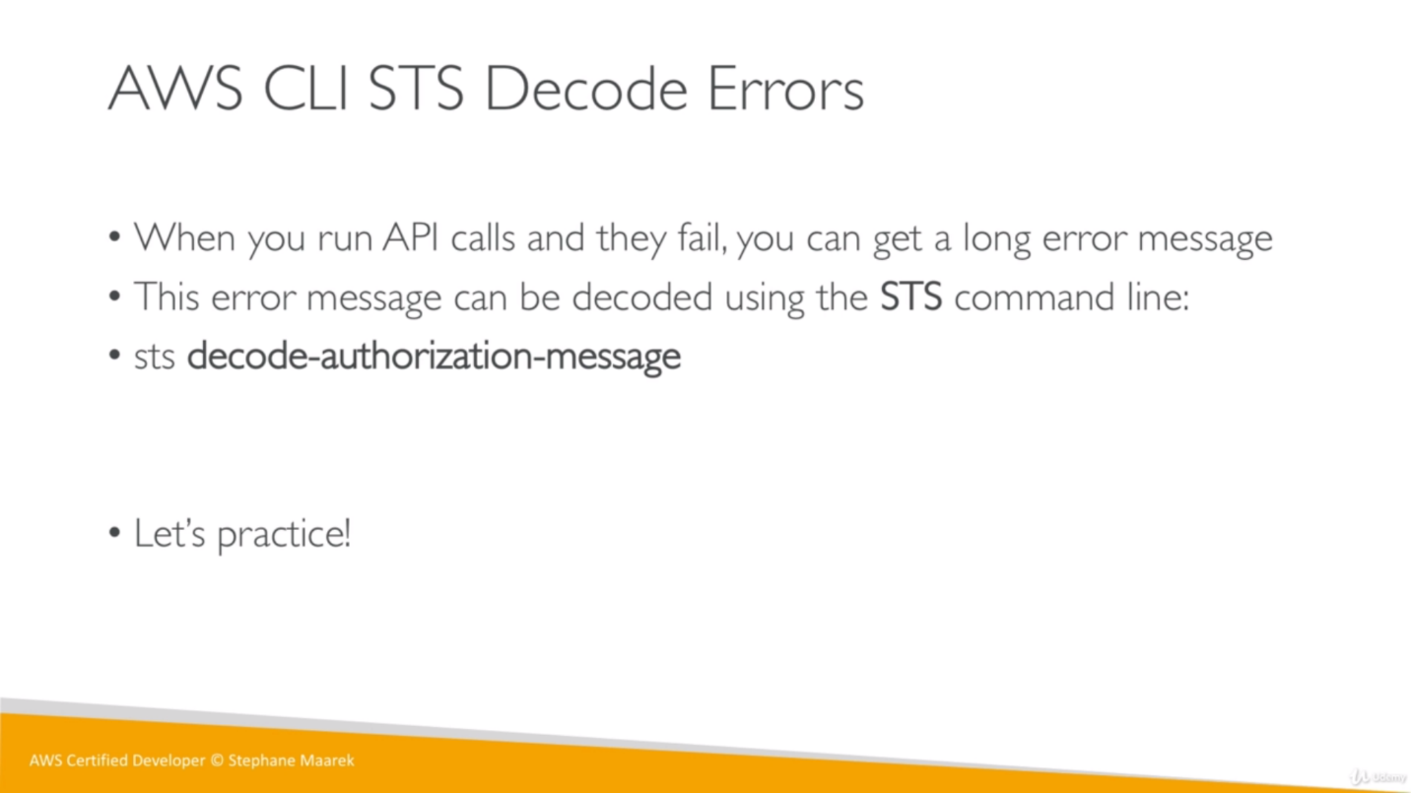

We can check aws documentation on google “aws sts decode-authorization-message” and will get all commands related to that.

For ex.

decode-authorization-message

--encoded-message <value>

[--cli-input-json <value>]

[--generate-cli-skeleton <value>]

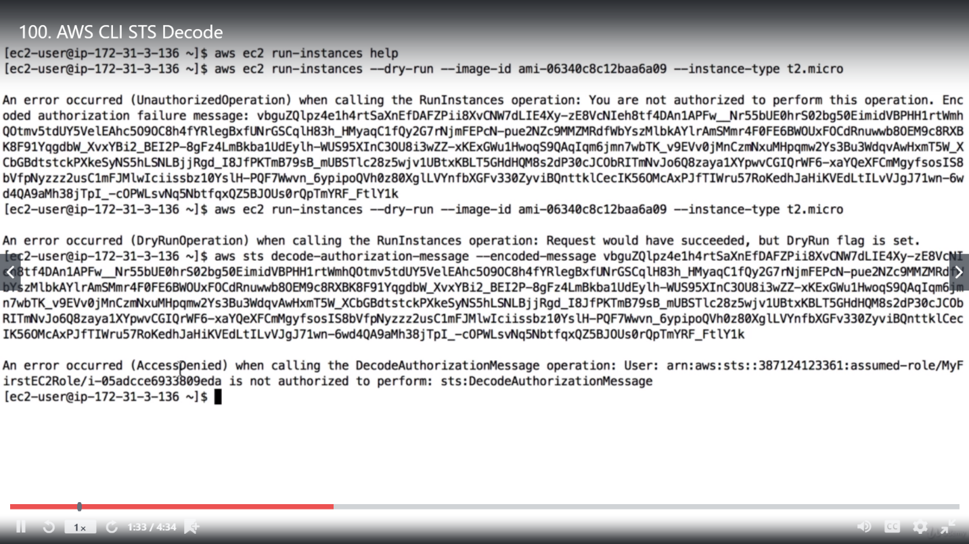

Now we got another error as our IAM role is not allowed to perform this operation, so we have to update the policy which is attached to EC2 instance that is getting used here.

In policy, choose STS and allow DecodeAuthorizationMessage operation as below:

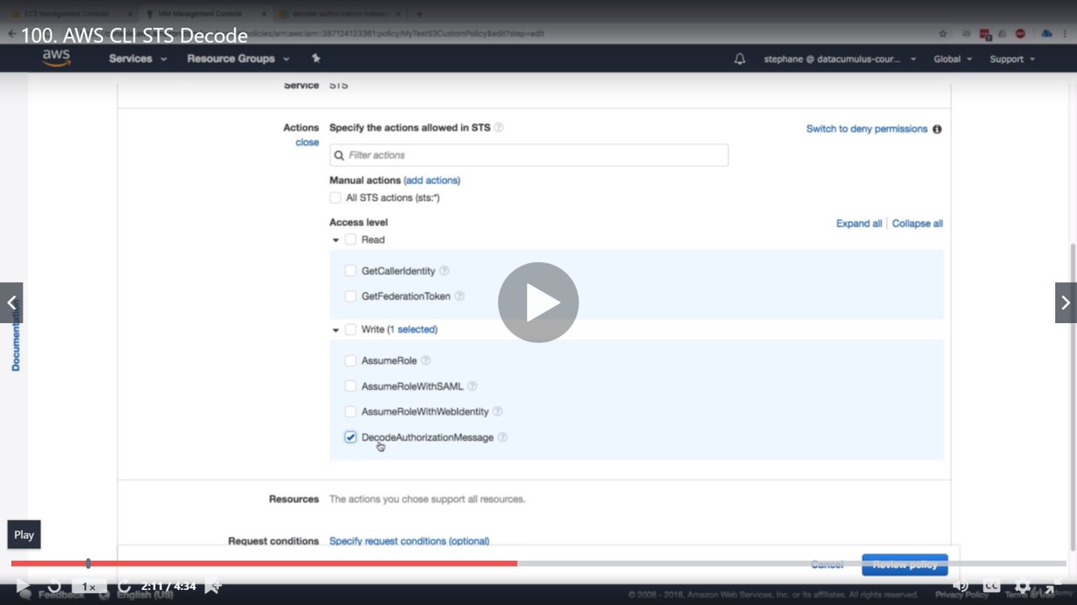

So now we can try the decode-authorization command and will get an output. If we echo this message, we will get a perfect JSON output.

**EC2 Metadata:**

As we know, we can check policy using policy simulator or test them using dry-run. There is no way to retrieve/download policy details, but we can retrieve IAM metadata using below link.

[http://169.254.169.254/latest/](http://169.254.169.254/latest/meta-data)

we will get 3 options, meta-data, user-data and dynamic.

IAM role doesn’t need any policy to access this information. All IAM roles can get this data.

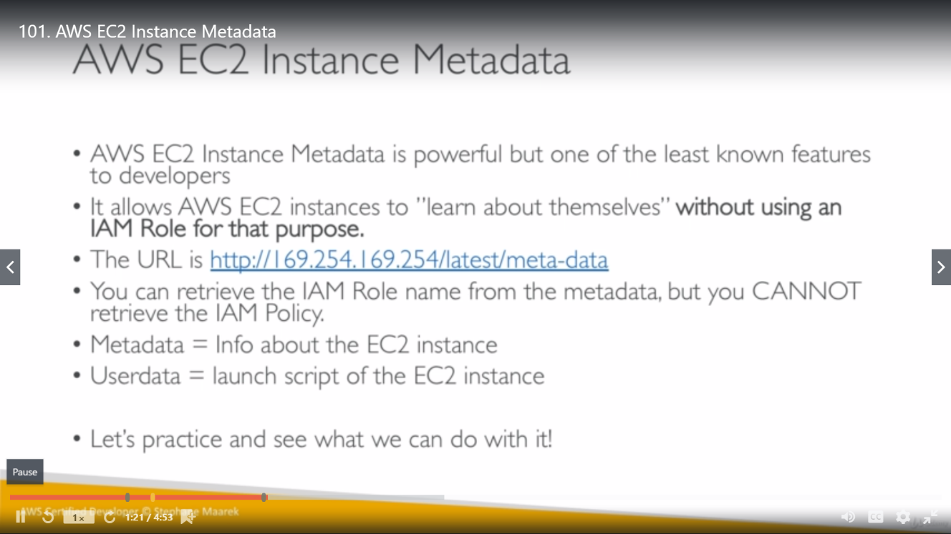

**curl:** query a URL.

So, whenever any request goes for

<http://169.254.169.254/latest/meta-data/iam/security-credentails/roleName>

behind the scene our EC2 instance is getting temporary credential through the IAM role that is attached to it. (short live credential nearly for one hrs).

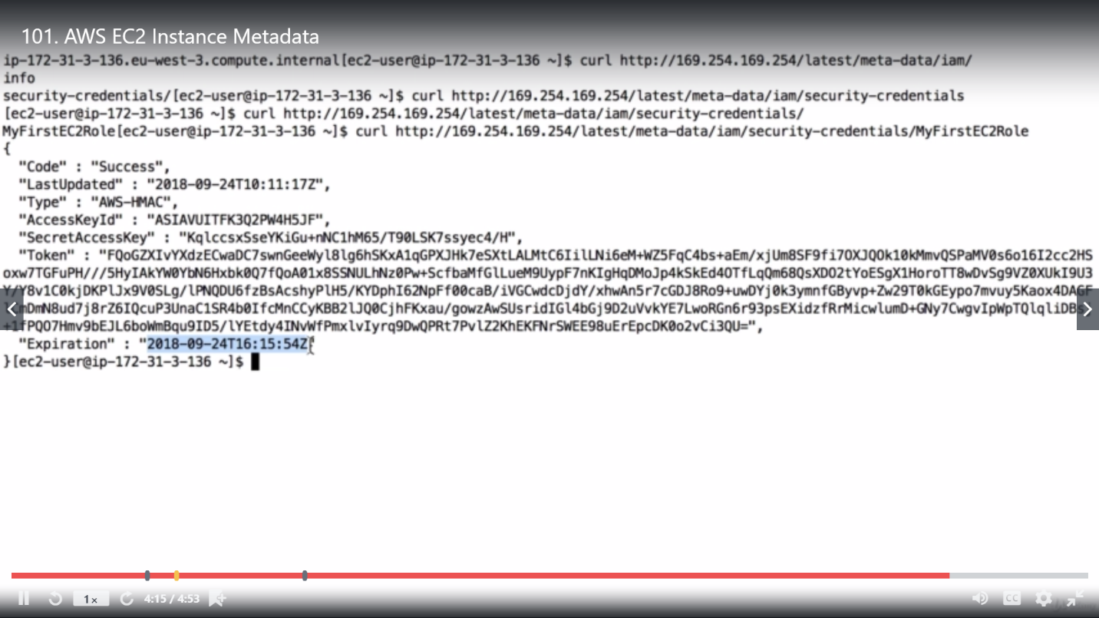

**AWS CLI Profiler**

We can create/configure a profile for aws user and later can use this profile.

So, we can run any command with this profile by extending the command with profile name.

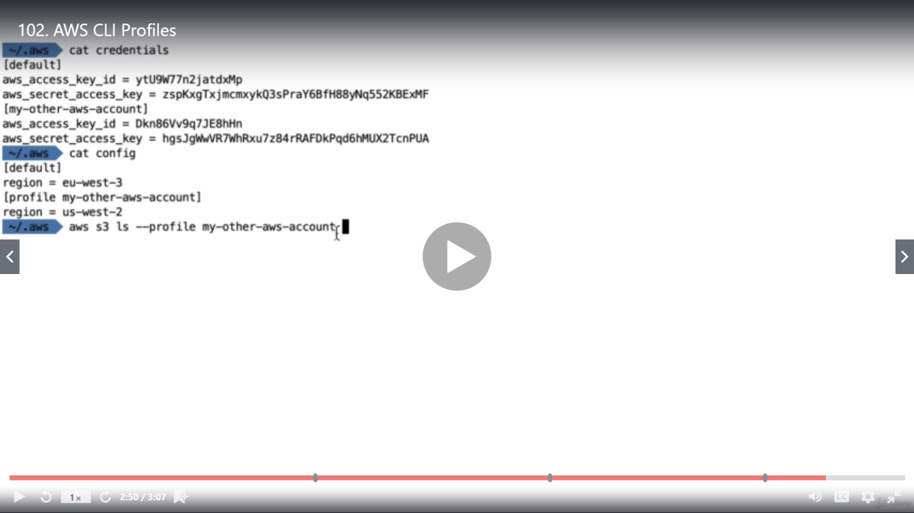

**MFA with CLI**

Multi Factor Authentication is extra authentication top of our credential. As for [vashistashwin@gmail.com](mailto:vashistashwin@gmail.com) , we are using google authentication.

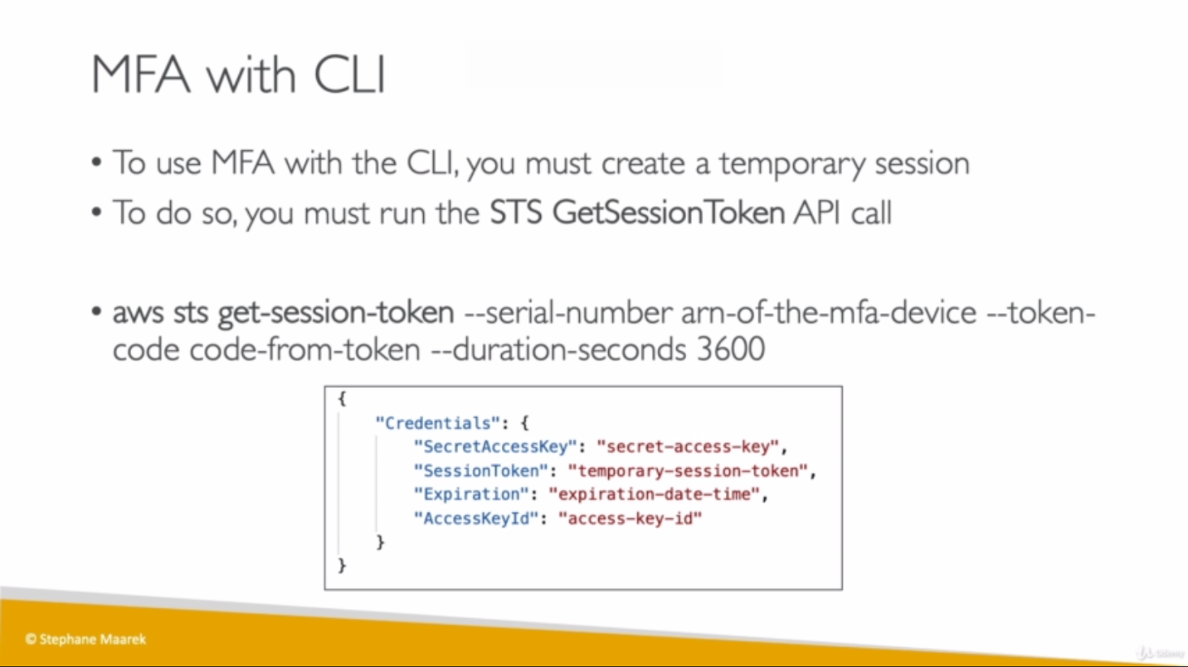

To do this from CLI, we must create a temporary session by running STS’s get-session-token api. We can take serial number from IAM user (Assigned MFA device) and token code that we get on our app. We will get temporary credential from this.

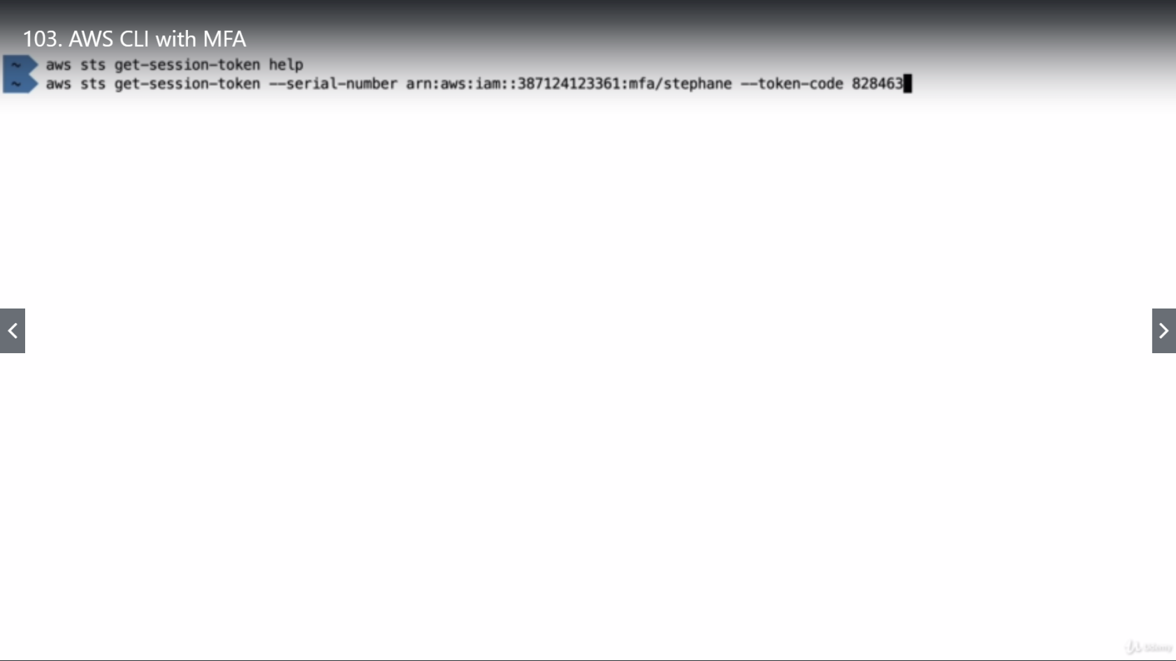

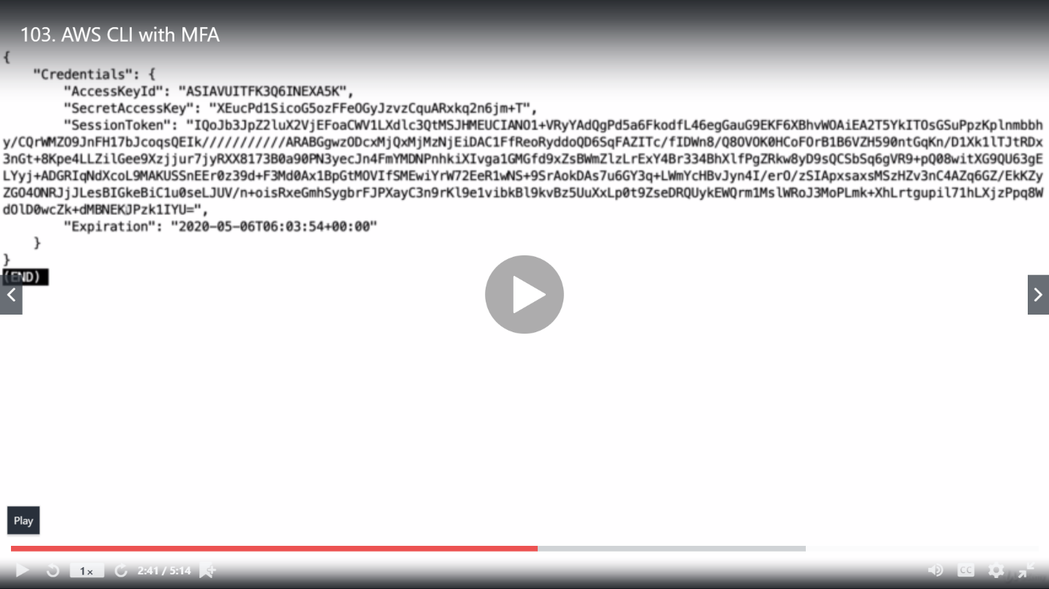

Didn’t do practical.

**AWS SDK:**

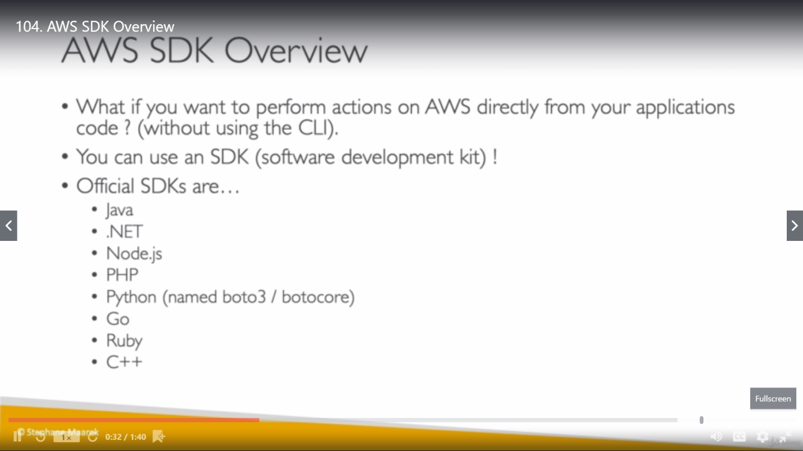

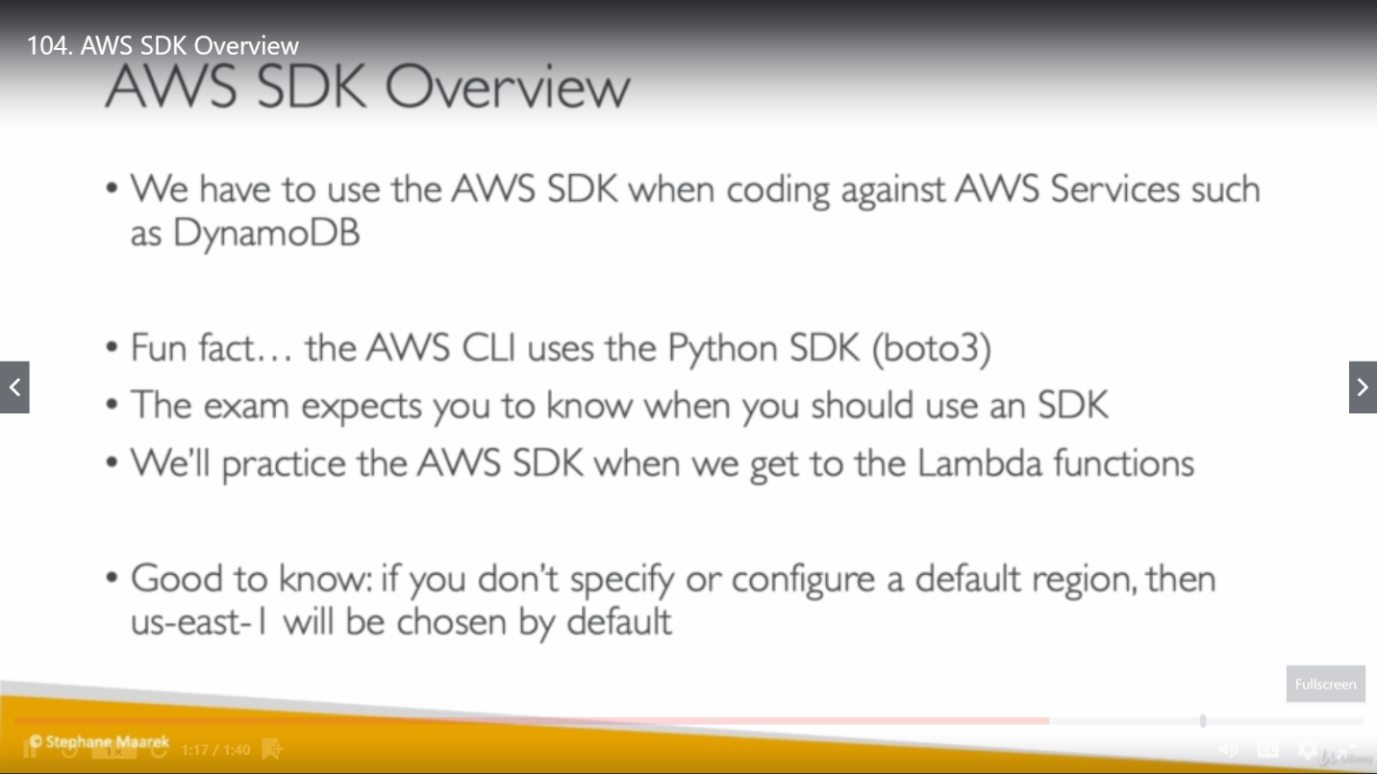

**AWS Limits (Quota):**

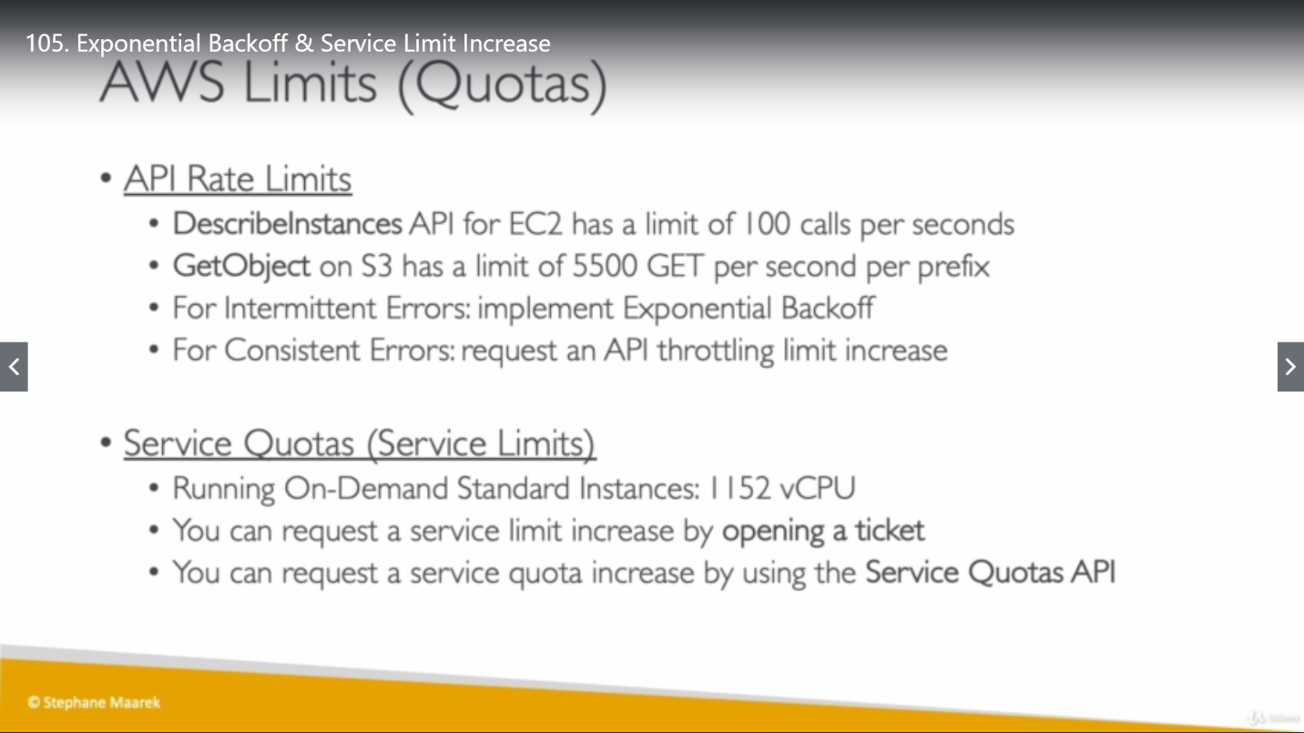

If we get ThrotteningException intermittently (We are going over the limit once in a while), we should use Exponential Backoff mechanism to resolve this issue.

**Exponential Backoff:** This is a Retry mechanism which already included in all the SDK by default. If we are using API without SDK then we must implement it with our self.

**Mechanism**: Every time we retry, we double the waiting time before retrying.

API calls:

1st: wait for 1 sec because it was failed

2nd: wait for 2 sec because it was failed

3rd: wait for 4 sec because it was failed

4th: wait for 8 sec because it was failed

and so on…

**AWS CLI credentials priority order: (Top to Bottom)**

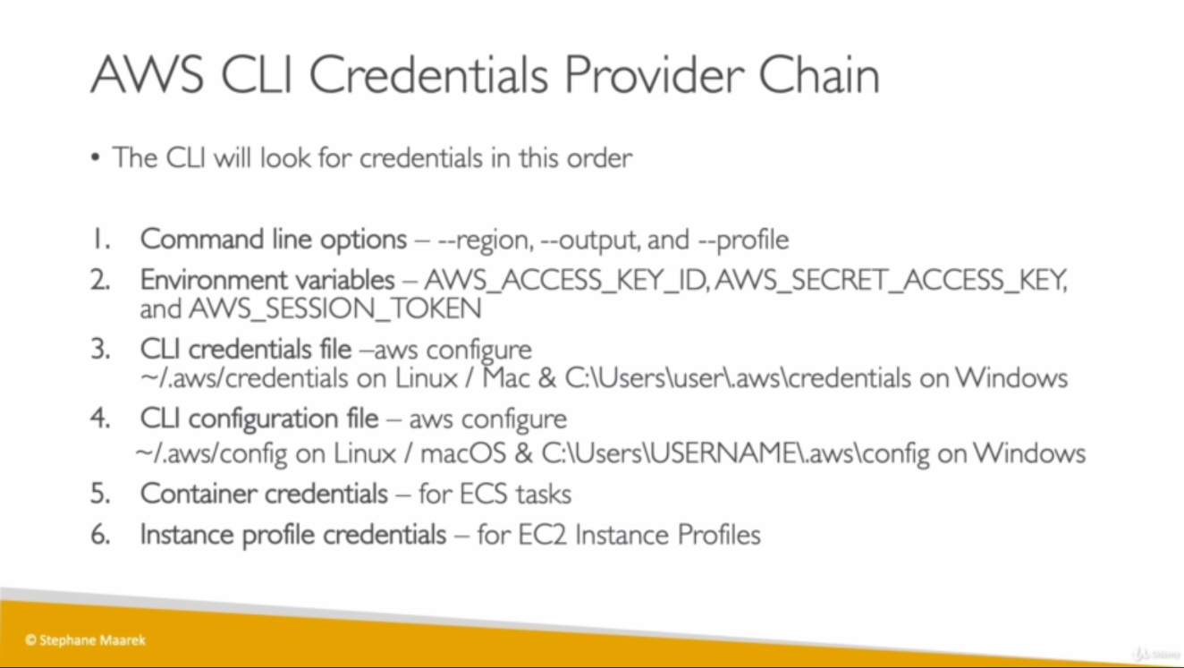

**AWS SDK credentials priority order: (Top to Bottom)**

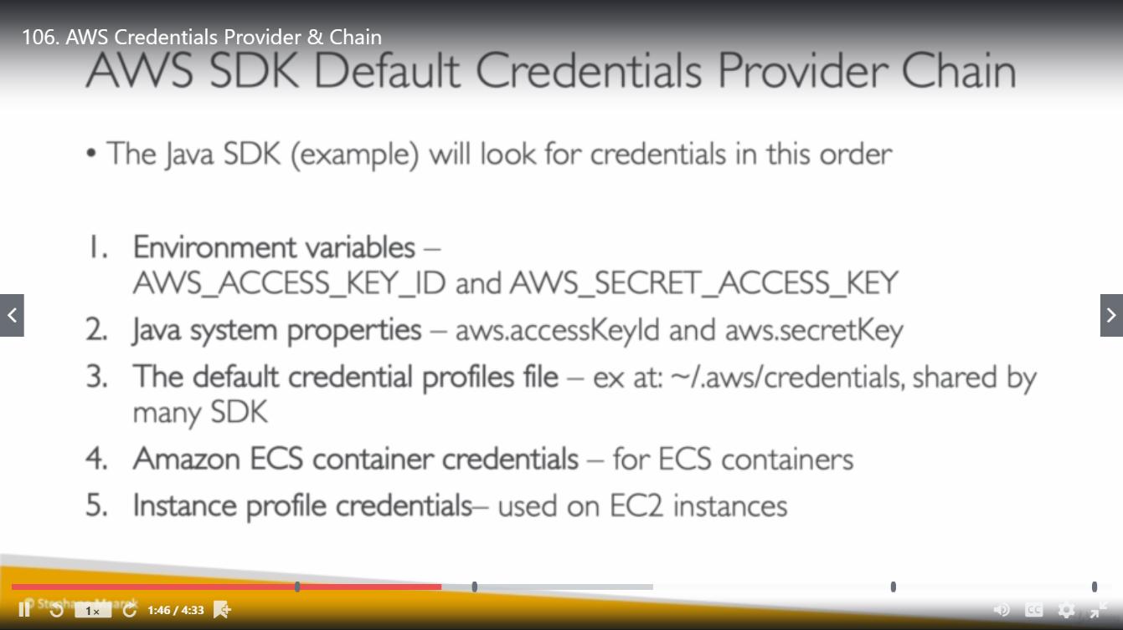

**Access related scenario:**

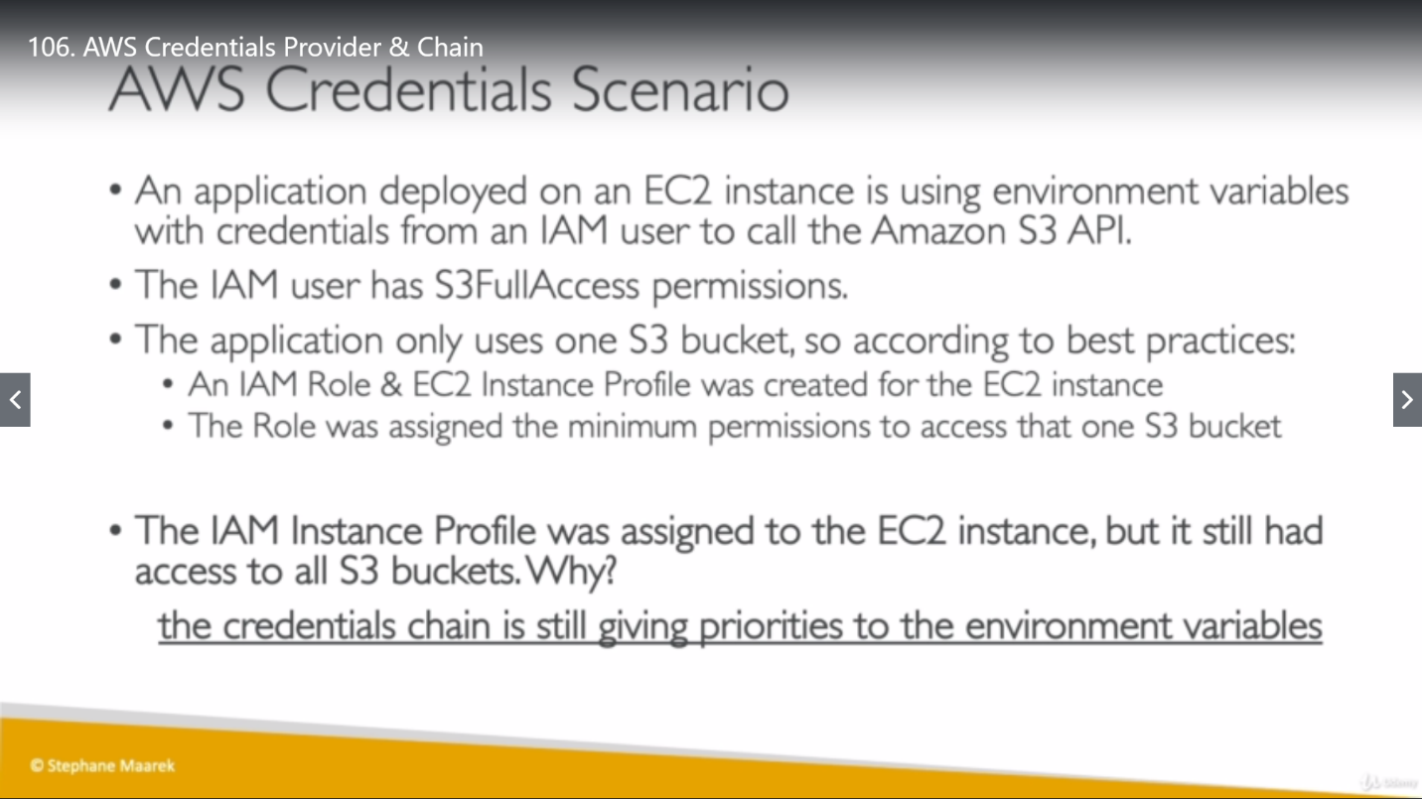

Here even though, role for instance was created to access only one bucket but we have configured into EC2 instance using IAM access key (environment variable), which will have higher priority so user will be able to access all S3 buckets from this instance.

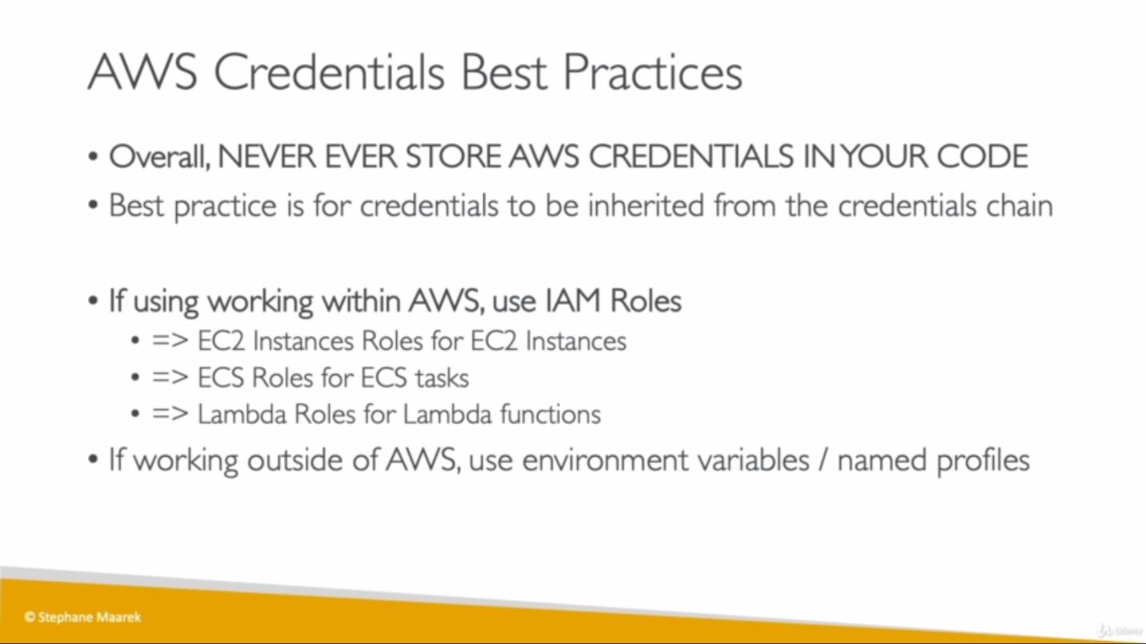

Quiz

